**Chapter 1**

**Introduction**

In the following sections, a brief introduction and motivation for undertaking the present study and the problem statement for the thesis has been included.

* 1. **Introduction**

As estimated by John et al. in [1], ……..The detailed review of related techniques has been given in [2, 3].

* 1. **Motivation**
  2. **Problem Statement**

The problem statement for the present work can be stated as follows:

…..

* 1. **Proposed Framework for**

Figure 1.1 Complex data mining framework

Feedback

Decision Making

Data

- value imputation

- Feature Extraction

Pre-Processing

Hybrid Techniques

Data Module

Knowledge Discovery

The proposed framework consists of the following modules:

1. *Data*.
2. *Pre-processing*
3. imputation, data normalization and feature extraction (we have focused on some of these issues).
4. *Data Module.*.
   1. **Organization of the Thesis**
      1. **Maximum Level list**
5. ***Sub section can be used if necessary beyond maximum level list***

Figure 1.2 **Wrapper method for feature selection**

Table 1.1 Pseudo code of the ABC algorithm

|  |
| --- |
| **Input.**  *D-* the dataset, *k-*the number of clusters and *α*-the fuzzifier  **begin**   1. Initialize *Z* by choosing *k* points from *D* randomly; 2. Initialize *W* with *wjh =* ; 3. Estimate *U* from initial values of *W* and *Z* according to Eq. 2.7. 4. Let *error = 1* and *Obj* = *Eα,ε(W,Z)*; 5. ***while*** *error > 0* ***do*** 6. Update *Z* according to Eq. 2.6 ; 7. Update *W* according to Eq. 2.5; 8. Update *U* according to Eq. 2.7; 9. Calculate *NewObj*= *Eα,ε(W,Z)*; 10. Let *error* = | *NewObj – Obj*|, and then *Obj* <= *NewObj* 11. ***end******while*** 12. Output *W, Z* and *U*   **End** |

**Chapter 2**

**Literature Review**

* 1. **Introduction**

**In the present times, research work is going on in context of ……In this chapter some of the major existing work in these areas has been reviewed.**

* 1. **Next Sub section**

Chapter 3

**Proposed Methods for**

C:\Program Files\Microsoft Office\MEDIA\CAGCAT10\j0199755.wmf

Figure 3.1 **Filter method for feature selection**

*RMSE = $\sqrt{\frac{{(p_{1}-q_{1})}^{2}+ … +{(p_{n}-q_{n})}^{2}}{n}}$*  (3.1)

Table 3.1 A list of some recent research works on classification

|  |  |  |  |
| --- | --- | --- | --- |
| **S. No.** | **Reference No.** | **Brief Description** | **Acronym/Short Name Introduced** |
| 1 | [112] | Classification | k-nn Fuzzy |
| 2 | [114] | Classification | LSSVM |
| 3 | [115] | Feature Selection and Classification | KFFS-LSSVM |
| 4 | [116] | Classifier Ensemble | AIRS-ICA |

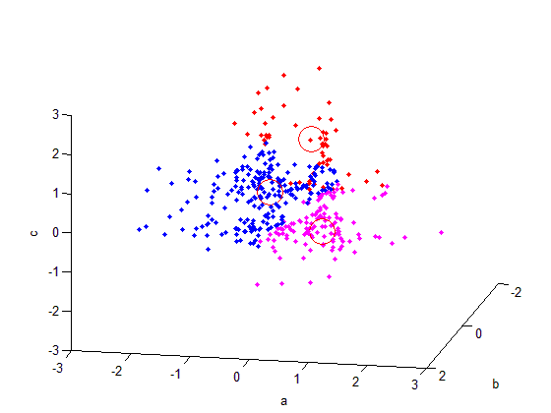

Figure 3.2 Clusters embedded in the along 3 different planes (Input to FSC)

References

1. T. Bodsky, R. Cohen, E. Cohen-Solal, S. Gutta, D. Lyons, V. Philomin and M. Trajkovic, “Visual surveillance in retail stores and in the home, ”*in Advanced Video-based surveillance Systems*, Kluwer Academic Publishers, Boston, Chapter 4, April 2001, pp. 50–61.
2. W. Niu, L. Jiao, D. Han and Y. Wang, “Real-time multi-person tracking in video surveillance, ” *Proc. of Pacific Rim Conf. on Multimedia*, Singapore, December 15-18, 2003, vol. 2, pp. 1144-1148
3. N. K. Kanhere and S. T. Birchfied, “Real-time incremental segmentation and tracking of vehicles at low camera angles using stable features,” *IEEE Trans. Intell. Transp. Syst*., vol. 9, no. 1, pp.148-160, March 2008
4. Open Source Computer Vision (OpanCV) [Online]. Available: http://opencv.willowgarage.com/wiki/
5. T. H. Cormen, C. E. Leiserson, R. L. Rivest and C. Stein, “*Computational Geometry*”, in Introduction to Algorithms, 2nd ed., The MIT Press, McGraw-Hill Book Company, 2001
6. K. Onoguchi, “Moving object detection using a cross correlation between a short accumulated histogram and a long accumulated histogram”, *Proc. 18th Int. Conf. on Pattern Recognition*, Hong Kong, August 20 - 24, 2006, vol. 4, pp. 896 – 899

Publications out of work

**International Journals:**

1. *.*
2. .

**International Conferences:**

1. .
2. .

**Communicated:**

1. *.*